WELCOME TO LAUREL WILD COMMUNITY CLASSES PROGRAM!

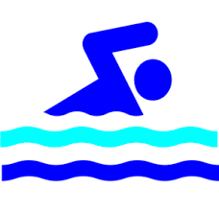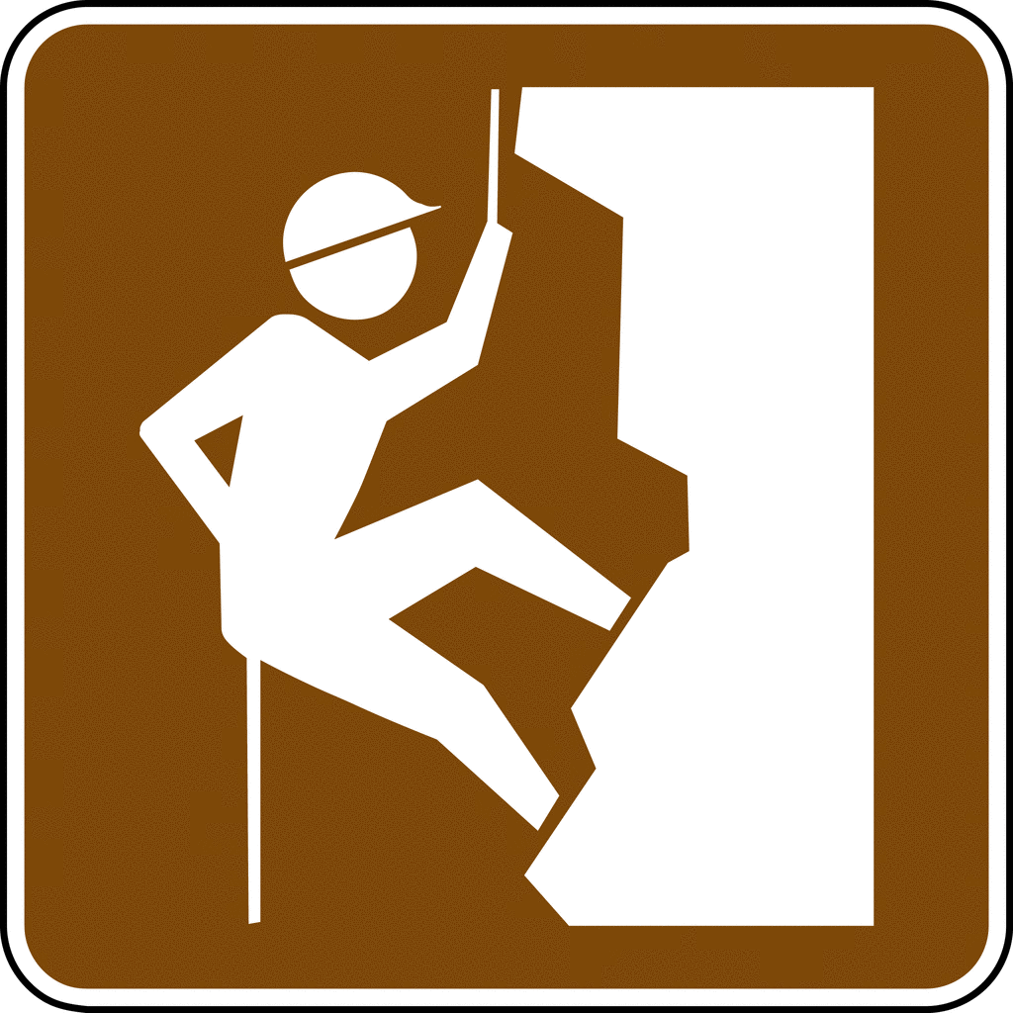

Students 1st- 8th grade will participate in enrichment classes within our community in the afternoons, after their core content classes. Laurel Tree students will join existing community programs, but with a curriculum catered to our students and their specific needs. They will strengthen their self awareness as active learners by setting personal and group goals as well as refine specific physical skills. I, Catherine, am the lead teacher and with me, our new aide and alum, Molly.

Students will be graded on participation, completion of weekly journal assignments, and applicable sustainability standards.

Safety is our #1 concern, as always, especially off campus. It is important for students to follow all safety rules. Your student will not be able to continue in these classes if they have unsafe or disrespectful behavior. Please see the note attached from Far North Climbing gym.

THANK YOU TO THE PARENT VOLUNTEER DRIVERS! We need additional parent volunteer drivers for back up/emergencies, please contact Catherine.

Catherine Bunz
520-490-0802
boringboris@hotmail.com

Identified standards and learning goals for these class are :
Water Safety

Body awareness, gross and fine motor skill refinement

Processing, analyzing, and responding to sensory information through the language and skills unique to music

Creating, performing, and participating in music

Expression and storytelling through own body

Sustainability standards including collaborative learning, setting goals and collective action*
* See addition info. on sustainability standards at the end of this packet
The weekly calendar will be the same each of the 7 weeks.

We will leave Laurel Tree 1:40pm, drive to our class that’s 2:00-3:00. If it’s easier for you, you may pick up your student onsite BY 3:15pm. Students needing aftercare/homework club will be driven back to Laurel Tree to get checked in by 3:30pm.

Friday, April 13th will be our potluck performance where students will show some of what they have been learning; The Inn at 2nd (Eagle House Eureka), doors at 5:30pm, food at 6pm, performance at 7pm.

- Mondays and Tuesdays students will receive swimming instruction at Healthsport Arcata: https://healthsport.com/aquatics/
- Wednesdays students will participate in music theatre/ improve class with KIDCO through the Humboldt Light Opera Company: http://www.hloc.org/kidco.html
- Thursdays Laurel Tree students receive rock climbing instruction at Far North Climbing Gym: http://www.farnorthclimbing.com/
- Fridays there are no afternoon programs, students dismissed 12:35 from L. T.

MONDAY | TUESDAY | WEDNESDAY | THURSDAY
February 26  Swim Healthsport | 27  Swim Healthsport | 28  KIDCO Musical Theatre | March 1  Rock Climbing
5  Swim Healthsport | 6  Swim Healthsport | 7  KIDCO Musical Theatre | 8  Rock Climbing
12  Swim Healthsport | 13  Swim Healthsport | 14  KIDCO Musical Theatre | 15  Rock Climbing
19  Swim Healthsport | 20  Swim Healthsport | 21  KIDCO Musical Theatre | 22  Rock Climbing
26  Swim Healthsport | 27  Swim Healthsport | 28  KIDCO Musical Theatre | 29  KIDCO Musical Theatre
April 2  Swim Healthsport | 3  Swim Healthsport | 4  KIDCO Musical Theatre | 5  Rock Climbing
9  Swim Healthsport | 10  Swim Healthsport | 11  KIDCO Musical Theatre | 12  Rock Climbing  POTLUCK  FRIDAY 13th

More information on the sustainability standards covered in this program:

National Education for Sustainability K-8 Student Learning Standards we will focus on:

2.4 Social and Cultural Systems (Family and Friends Personal Identity Happiness Fairness Collaborative Learning):
Personal Identity - Students develop a sense of unique worth and personal competence.
Collaborative Learning - Students perform effectively on teams that set and achieve goals, conduct investigations, solve problems, and create solutions (e.g., by using consensus-building and cooperation to work toward group decisions).

3.1 Personal Action: Setting Goals Communicating Ideas Making a Difference
Setting Goals - Students assess their own learning by developing criteria for themselves, and use these to set goals and produce high-quality work.
Communicating Ideas - Students use different media to share ideas with diverse audiences.
Making a Difference - Students take an active role in their community and feel a locus of control or self-efficacy. Students understand that everyone has the ability to affect change or impact a system, community, and self.

3.2 Collective Action: Setting Goals Working Together
Setting Goals - Students work cooperatively and respectfully with people of various groups to set community goals and solve common problems.
Working Together - Students perform effectively on teams that set and achieve goals, conduct investigations, solve problems, and create solutions (e.g., by using consensus-building, conflict resolution, and cooperation to work toward group decisions). Students use systematic and collaborative problem-solving processes, including mediation, to negotiate and resolve conflicts. Students respect and value human diversity as part of a multicultural society and world

